Open the url https://leaftaps.com/opentaps/control/main in chrome browser. Then open the “AI Browser Extension for Code Generation” extension in the chrome browser
Open the VSCode and load ”ai-extension” folder where “manifest.json” is available.
Enter the below prompt in co-pilot to enable the Playwright\Typescript option for Code Generator extension
Prompt –“ Go through the entire workspace structure and understand the implementation for Selenium with Java.
I want to implement the same with Playwright with Typescript.
Please tell me the impacted files”
Close the “AI Browser Extension for Code Generation” and reopen it in the browser
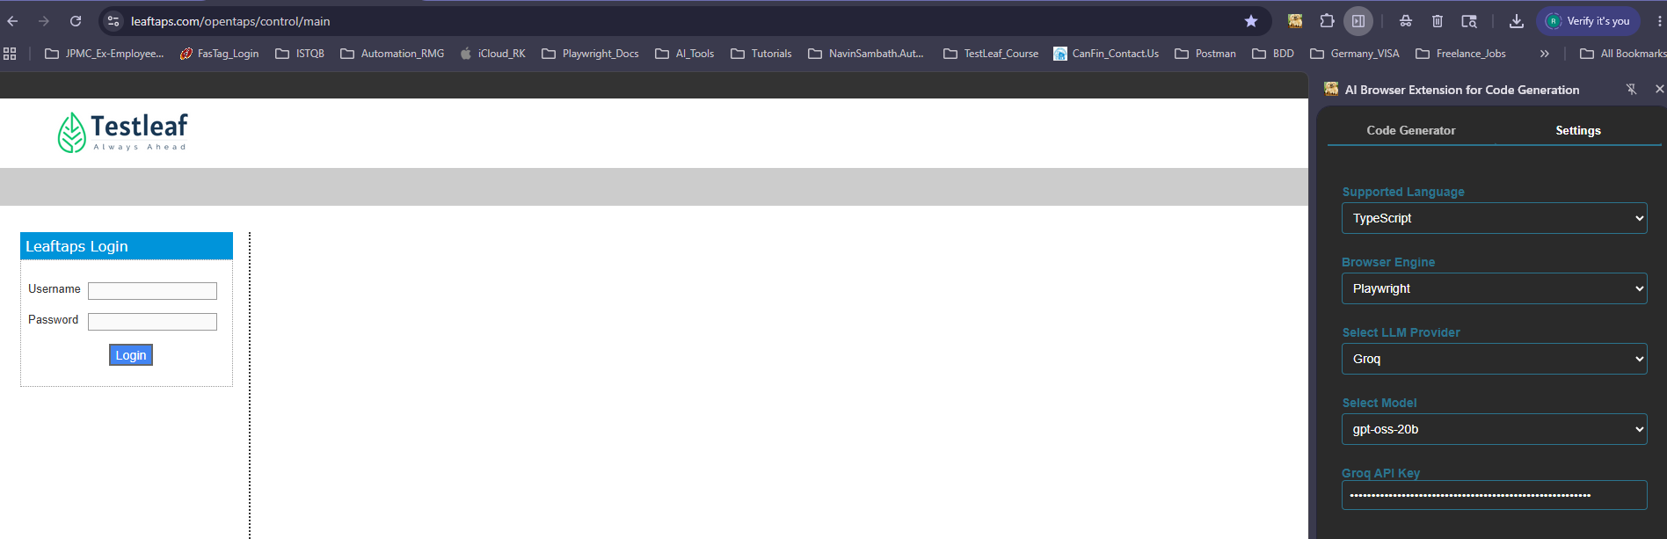
VSCode with Playwright\Typescript Enabled:
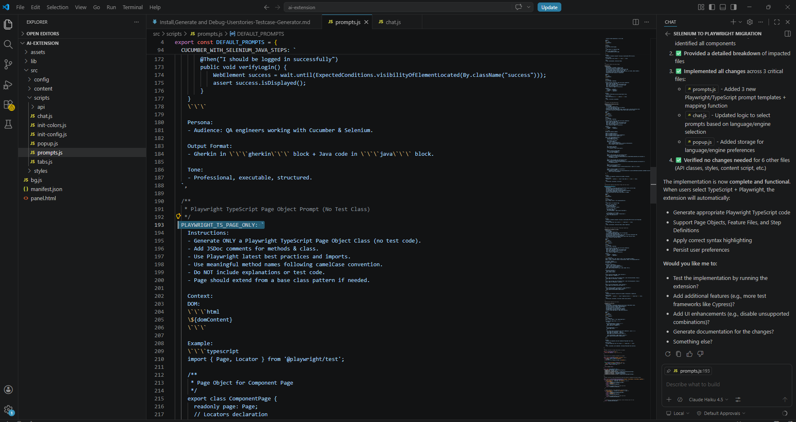

Code Generated using the extension:
Code GeneratorSettings
Feature File Page Class
Reset Chat

Feature: Login to OpenTaps

Scenario Outline: Successful login with valid credentials
Given I open the login page
When I type "<username>" into the Username field
And I type "<password>" into the Password field
And I click the Login button
Then I should be logged in successfully

Examples:
| username | password |
| suresh_kumar | Suresh@1234 |
| arun_mohan | Arun@5678 |
| meena_raj | Meena@9012 |

import { Given, When, Then, Before, After } from '@cucumber/cucumber';
import { expect, chromium, Browser, BrowserContext, Page } from '@playwright/test';

let browser: Browser;
let context: BrowserContext;
let page: Page;

Before(async function () {
browser = await chromium.launch({ headless: false });
context = await browser.newContext();
page = await context.newPage();
await page.setViewportSize({ width: 1280, height: 720 });
});

After(async function () {
await context.close();
await browser.close();
});

Given('I open the login page', async function () {
await page.goto('https://leaftaps.com/opentaps/control/main', { waitUntil: 'networkidle' });
// Ensure the login form is present before proceeding
await expect(page.locator('#login')).toBeVisible();
});

When('I type {string} into the Username field', async function (username: string) {
await page.fill('#username', username);
});

When('I type {string} into the Password field', async function (password: string) {
await page.fill('#password', password);
});

When('I click the Login button', async function () {
// Wait for the submit button to be enabled and visible
const loginButton = page.locator('input[type="submit"][value="Login"]');
await expect(loginButton).toBeEnabled();
await loginButton.click();
// Wait for navigation or network idle after login
await page.waitForLoadState('networkidle');
});

Then('I should be logged in successfully', async function () {
// Replace the selector below with the actual element that appears after a successful login
const dashboard = page.locator('#welcome, .dashboard, .home-page');
await expect(dashboard).toBeVisible({ timeout: 10000 });
});

Page Class
import { Page, Locator } from '@playwright/test';
/**
* Page Object representing the login form.
*
* @class LoginPage
*/

export class LoginPage {
readonly page: Page;
readonly usernameInput: Locator;
readonly passwordInput: Locator;
readonly loginButton: Locator;
/**
* Creates an instance of LoginPage.
* @param {Page} page - Playwright Page instance.
*/
constructor(page: Page) {
this.page = page;
this.usernameInput = page.locator('#username');
this.passwordInput = page.locator('#password');
this.loginButton = page.locator('form#login .decorativeSubmit');
}
/**
* Navigates to the specified URL.
* @param {string} url - The URL to navigate to.
* @returns {Promise<void>}
*/
async navigateTo(url: string): Promise<void> {
await this.page.goto(url);
}
/**
* Enters the username into the username field.
* @param {string} username - The username to enter.
* @returns {Promise<void>}
*/
async enterUsername(username: string): Promise<void> {
await this.usernameInput.fill(username);
}

/**
* Enters the password into the password field.
* @param {string} password - The password to enter.
* @returns {Promise<void>}
*/
async enterPassword(password: string): Promise<void> {
await this.passwordInput.fill(password);
}

/**
* Clicks the login button to submit the form.
* @returns {Promise<void>}
*/
async clickLogin(): Promise<void> {
await this.loginButton.click();
}

/**
* Performs a full login action.
* @param {string} username - The username to use.
* @param {string} password - The password to use.
* @returns {Promise<void>}
*/
async login(username: string, password: string): Promise<void> {
await this.enterUsername(username);
await this.enterPassword(password);
await this.clickLogin();
}

/**
* Returns the locator for the username input.
* @returns {Locator}
*/
getUsernameInput(): Locator {
return this.usernameInput;
}

/**
* Returns the locator for the password input.
* @returns {Locator}
*/
getPasswordInput(): Locator {
return this.passwordInput;
}

/**
* Returns the locator for the login button.
* @returns {Locator}
*/
getLoginButton(): Locator {
return this.loginButton;
}
}

